Sultan Qaboos University – College of Science
Department of Computer Science
Data Exploration and Visualization Spring26
Dr. Hamza ZIDOUM
Assignment2: Descriptive Statistics
Gapminder dataset will be used for a lab session on descriptive statistics and visualization. It’s widely used in teaching because it’s intuitive, global in scope, and rich in variables.
https://www.gapminder.org/data/
Choose individual indicators from the menu that lists all indicators available in Gapminder. First we are interested in the Breast Cancer deaths: total number of female deaths due to breast cancer during certain year.
Please find the indicator from sub-category “Health” -> “Cancer, female” -> Breast c. deaths
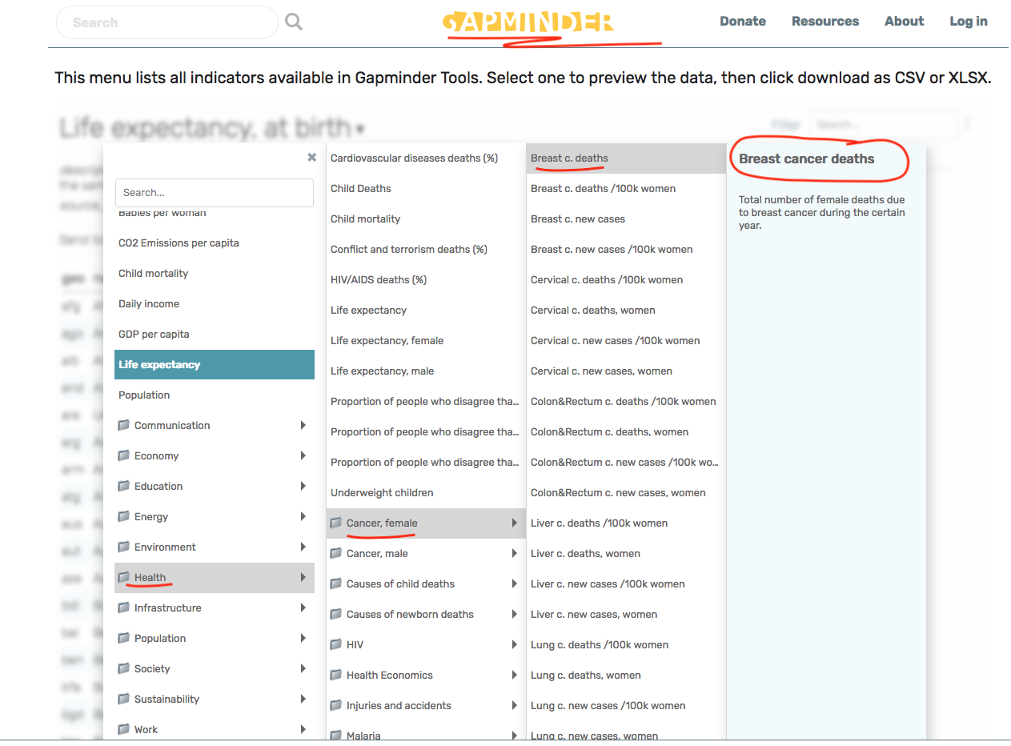
- Univariate Analysis:
  - Calculate mean, median, variance, and standard deviation of breast cancer mortality rates globally.
  - Identify countries with extreme values (outliers).
- Group Comparisons
  - Histograms of mortality rates.
  - Scatterplots of breast cancer mortality vs. GDP per capita.
  - Time-series plots showing changes in mortality rates over decades.
- Visualization
  - Compare average breast cancer mortality across regions of interest, continents, etc.
  - Use boxplots to visualize differences between high-income vs. low-income countries.
- Interpretation
- Discuss what descriptive statistics reveal about global health inequalities.
- Highlight regions with higher variability and possible other factors (socio-economic, environmental, etc.)

Deliverables
Students must submit an individual report formatted according to the IEEE Conference format (see the provided file: IEEE_Gapminder_Breast_Cancer_Paper.docx).

The report must contain the following sections with the clarifications below::
- Introduction
- (Your) Research Question (s)
- Data and Methodology
- Analysis & Visualization
- Interpretation
- Insights & Conclusion

Additional Formatting Requirements

Professional academic tone.
Figures and tables must be referenced in the text.
No screenshots — use clean exported figures.
Proper citation of data source (Gapminder).
Length guideline: 4–6 pages.

